Name: Allen Taylor
CMIS 310
HOMEWORK #5 – Week #5

This homework is worth 10% of your course grade.

Read each problem carefully. Failure to follow the instructions for a problem will result in a zero score for that problem.

Submit the completed Homework via Assignment in LEO.

- Do Exercise 2 in Chapter 6 (Memory) of Null and Lobur

Suppose a computer using direct-mapped cache has 2^32 bytes of byte-addressable main memory and a cache of 1024 blocks, where each cache block contains 32 bytes.

a) How many blocks of main memory are there?
Main Memory = 2^32
32 bytes = 2^5
Blocks of Main Memory = 2^ 32 / 2^5 = 2^27 = 134,217,728

b) What is the format of a memory address as seen by the cache; that is, what are the sizes of the tag, block, and offset fields?
Main Memory = 2^32
1024 blocks = 2^10 block bits
32 bytes = 2^5 offset bits
32 - 15 = 17 tag bits
Tag: 17 bits | Block: 10 bits | Offset: 5 bits

c) To which cache block will the memory address 0x000063FA map?

000063FA = 0000 0000 0000 0000 0110 0011 1111 1010
1100011111 = Block 799

- Do Exercise 5 in Chapter 6 (Memory) of Null and Lobur

Suppose a computer using fully associative cache has 2^24 bytes of byte-addressable main memory and a cache of 128 blocks, where each cache block contains 64 bytes.

a) How many blocks of main memory are there?
Main Memory = 2^24
64 bytes = 2^6
Blocks of Main Memory = 2^24 / 2^6 = 2^18 = 262,144

b) What is the format of a memory address as seen by the cache; that is, what are the sizes of the tag and offset fields?
Main Memory = 2^24
64 bytes = 2^6 offset bits
24 - 6 = 18 tag bits
Tag: 18 bits | Offset: 6 bits

c) To which cache block will the memory address 0x01D872 map?

A fully associative cache allows a main memory block to be mapped to any block in cache.

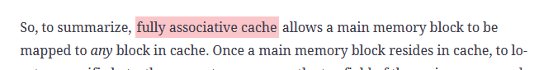

- Do Exercise 8 in Chapter 6 (Memory) of Null and Lobur

A 2-way set-associative cache consists of four sets. Main memory contains 2K blocks of 8 bytes each and byte addressing is used.

a) Show the main memory address format that allows us to map addresses from main memory to cache. Be sure to include the fields as well as their sizes.

2^11 * 2^3 = 2^14 = 14 bits
4 sets = 2^2 set bits
8 bytes = 2^3 offset bits
14 - 5 = 9 tag bits
Tag: 9 bits | Set: 2 bits | Offset: 3 bits

b) Compute the hit ratio for a program that loops three times from addresses 0x8 to 0x33 in main memory. You may leave the hit ratio in terms of a fraction.

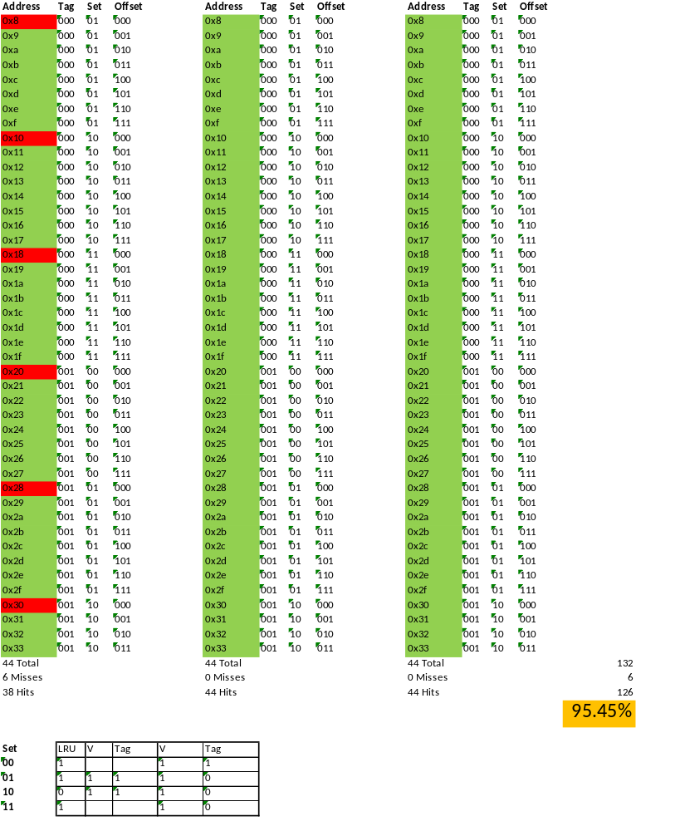

- Do Exercise 10 in Chapter 6 (Memory) of Null and Lobur

Suppose a byte-addressable computer using set-associative cache has 2^21 bytes of main memory and a cache of 64 blocks, where each cache block contains 4 bytes.

a) If this cache is 2-way set associative, what is the format of a memory address as seen by the cache; that is, what are the sizes of the tag, set, and offset fields?

Main Memory = 2^21
64/2 = 32 = 2^5 set bits
4 = 2^2 offset bits
21 – 7 = 14 tag bits
Tag: 14 bits | Set: 5 bits | Offset: 2 bits

b) If this cache is 4-way set associative, what is the format of a memory address as seen by the cache?

Main Memory = 2^21
64/4 = 16 = 2^4 set bits
4 = 2^2 offset bits
21 – 6 = 15 tag bits
Tag: 15 bits | Set: 4 bits | Offset: 2 bits

- Do Exercise 18 in Chapter 6 (Memory) of Null and Lobur

Suppose a process page table contains the entries shown below. Using the format shown in Figure 6.22a, indicate where the process pages are located in memory.

